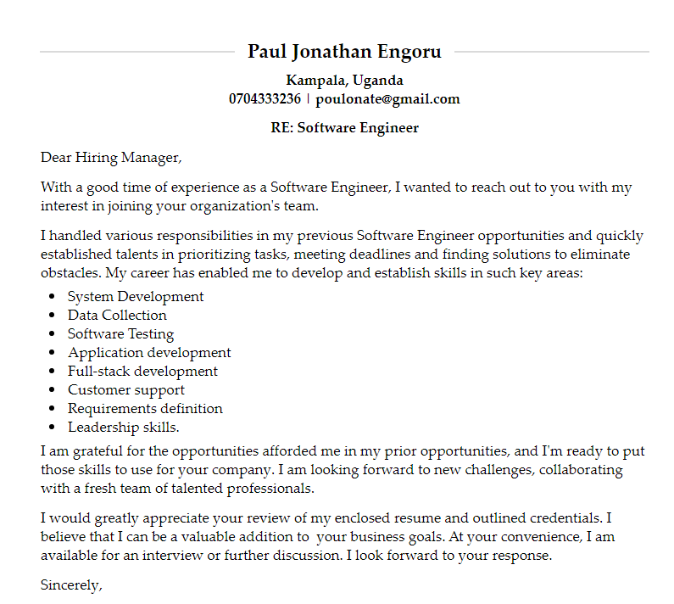

CURRICULUM VITAE

PERSONAL INFORMATION

|  |  |
| --- | --- |
| **NAME** | **:**  **ENGORU PAUL JONATHAN** |
| **DATE OF BIRTH** | **:** 23/12/1995 |
| **SEX** | **:** MALE |
| **NATIONALITY** | **:** UGANDAN |
| **MARITAL STATUS** | **:** SINGLE |
| **MOBILE** | **:** 0704333236 |
| **Email** | **:** poulonate@gmail.com |

PERSONAL PROFILE

I am an enthusiastic Ugandan who is honest, hardworking, proactive, confident, intelligent, and eager to learn with strong networking and communication skills. I am a dependable, self-driven team player who believes in collective responsibilities in achieving a common goal beyond established expectations and always brings out and promotes the strengths of others. Paul is a fast learning individual who easily adapts to new environments with a passion for excellence, strong commitment, and dedication and is able to work under minimum supervision.

CAREER OBJECTIVE

To professionalize in Programming, Desktop Applications, Website Designer and System’s Administration. This will help me gain insight in invention and innovation of high quality affordable and sustainable products that meet the society’s current needs. I intend to further my studies in the fields of Programming, Software Engineering and System Administration, which will give me a better platform to benefit the industry.

SUMMARY

Driven Programmer Analyst with excellent experience and highly developed skills in programming and systems analysis. Accomplished in creating project parameters based on client specifications and tailored to individual users' needs. Talented in providing outstanding and effective solutions while managing project deadlines to deliver work on time.

EDUCATION BACKGROUND

|  |  |  |
| --- | --- | --- |
| **YEAR** | **INSTITUTION** | **Qualification** |
| 2018-2021  2016-2017 | Aptech Computer Center  Rock High School, Tororo | Software Engineering  Uganda Advanced Certificate of Education |
| 2012-2015 | Otino Waa Comprehensive Secondary School | Uganda Certificate of Education |
| 2005-2011 | Otino Waa Primary School | Primary Leaving Examination |

EXPERIENCE

**March 2016 to June 2018:** Cosmetics and Beauty Business.

* Purchasing the stock; cosmetics, braids and hair accessories.
* Balancing the books of accounts.
* Provided advisory services to the customers on the right products for them, like the right cosmetics for their skin, right weave or braids and color.
* Selling in the counter of the shop.
* Opening and closing the shop.

**February-2021 to August-2021**: Systems Administrator, Internship at Post Bank City.

* Provide technical support and advice as required across the HR and Payroll Management System, Procurement and Disposal Management System, Assets Management System and IT users.
* Responding in a timely manner to service issues and requests.
* Provide additional training to the required users.
* To monitor and keep a log of all issues and changes in the system.
* Test and evaluate the new changes or updates in the system with the users.
* Support rollout of e-Recruitment and other modules.
* Coordinate the project management tasks.
* Prepare and Submit Weekly Report to the head of IT.

**February-2021 to August-2021**: Programmer Analyst Trainee, Future Technologies Limited.

* Designed and implemented solutions by examining customer needs.
* Resolved customer issues by establishing workarounds and solutions to debug and create defect fixes.
* Collected information by meeting with database architects and administrators to determine client system limitations for capacity and load for System data processing projects.
* Uncovered system issues by troubleshooting hardware and testing code at project intervals.
* Coordinated installation of software systems and collaborated with user experience team on design and implementation of new features.
* Regularly reviewed project documentation and made all-important changes to match updates to project scope.
* Performed tests and carefully reviewed work to verify quality.
* Resolved many issues by debugging software and hardware.
* Troubleshot malfunctions with systems and programs to pinpoint root cause of issues and restore.
* Collaborated with product and engineering team members to define and develop new product concepts.
* Trained end-users in best practices to minimize errors and protect key data.
* Developed logic flowcharts and diagrams to use in program coding workflow planning.

# Responsibilities Held

**2018-2021**: Worship Leader at Watoto Church

**2016-2017**: TOT in DML and Youth Leader at PAG Tororo.

**2012-2015**: Students’ Bee Manager at Otino Waa Children’s Village

**2013- 2015**: Vice president of Science club, Otino Waa Comprehensive Secondary School.

**2007-2010**: Class monitor, Otino Waa Primary School.

|  |  |
| --- | --- |
| **Skills and competences** | **Unique attributes** |
| * Microsoft Suite Package * Proficient in C#, Java, PHP, Java Script, HTML5 and CSS * Quality assurance testing * Project development * Debugging * Developing databases * Application development * Object oriented languages * Developing tests * Full-stack development * Software testing * Customer support * Expertise in HTML5, PHP and C# * Requirements definition * Client implementation support | * Self -driven * Team work at all levels * Initiate and coordination   programs. * Ability to work under pressure. * Leadership skills. |

|  |  |  |  |
| --- | --- | --- | --- |
|  | **LANGUAGES** |  | **HOBBIES** |
| •  •  •  •  • | English – Fluent  Kumam – Very Good  Luo – Very Good  Swahili - Good  Luganda – Fair | •  •  •  •  • | Making Music  Playing guitar  Visiting and interacting with friends Listening to gospel music.  Indoor games. |

**REFEREES**

|  |  |  |
| --- | --- | --- |
| **Rev. Dickens Oyup**  Administrator, Otino Waa. P.O. Box. 117, Lira. Tel: 075675588 | **Dr. Wanjala Geoffrey**  The Karen Hospital  Tel: +256 772423428 | **Mr. Esolu Steven**  Easter Coordinator FUO Mbale.  Tel: +256 703313207 |
|  |  |  |

**Pastor Moses Onyonge.**

Royal Life World Ministries.

Tel: +256 757861853.